**SQL Assignment-4**

1. Create a stored procedure in the Northwind database that will calculate the average value of Freight for a specified customer.Then, a business rule will be added that will be triggered before every Update and Insert command in the Orders controller,and will use the stored procedure to verify that the Freight does not exceed the average freight. If it does, a message will be displayed and the command will be canceled.

**Query:**

**Average_procedure**

CREATE PROCEDURE `avg_freight_cal`(in customer_id varchar(5),out average float )

BEGIN

select avg(freight) as average into average from orders where customerid=customer_id;

END

call avg_freight_cal("vinet",@average);

select@average as average ;

**Output:**

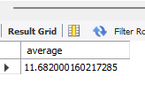

**Insert trigger**

DELIMITER &&

create trigger avg_freight_calc

before insert on orders for each row

begin

declare msg varchar(100);

SET msg = 'The command will cancel due to the exceed average of freight column ';

call avg_freight_cal(new.customerid,@average);

if @average < new.freight then

SIGNAL SQLSTATE '45000' SET MESSAGE_TEXT = msg;

end if ;

end &&

delimiter ;

**Output:**

insert into orders

values(10257,"hilaa",4,"2000-05-01","2000-05-01","2005-03-02",1,70.23,null,null,null,null,null,null);



**Update trigger**

DELIMITER &&

create trigger avg_freight_calc_update

before update on orders for each row

begin

declare msg varchar(100);

SET msg = 'The command will cancel due to the exceed average of freight column';

call avg_freight_cal(new.customerid,@average);

if @average < new.freight then

SIGNAL SQLSTATE '45000' SET MESSAGE_TEXT = msg;

end if ;

end &&

delimiter ;

**Output:**

update orders

set Freight=70.23

where customerid = "hilaa";



1. write a SQL query to Create Stored procedure in the Northwind database to retrieve Employee Sales by Country

**Query:**

CREATE PROCEDURE `Emp_Sales_Country`(In country varchar(30))

BEGIN

SELECT emp.FIRSTNAME,emp.LASTNAME,orders.SHIPCOUNTRY AS COUNTRY,COUNT(ORDERID) AS SALES FROM EMPLOYEES EMP LEFT JOIN ORDERS

ON EMP.EMPLOYEEID = ORDERS.EMPLOYEEID

WHERE SHIPCOUNTRY = country

GROUP BY shipCOUNTRY,emp.FIRSTNAME,emp.LASTNAME;

END

call Emp_Sales_Country("usa");

**Output:**

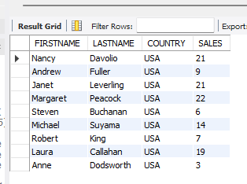

1. write a SQL query to Create Stored procedure in the Northwind database to retrieve Sales by Year

**Query:**

CREATE PROCEDURE `SalesbyYear`( In startdate date , In enddate date)

BEGIN

select count(orderID) AS TOTAL_SALES from orders

WHERE SHIPPEDDATE BETWEEN startdate AND enddate;

END

call SalesbyYear("1996-06-01","1997-02-15");

**Output:**

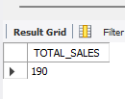

1. write a SQL query to Create Stored procedure in the Northwind database to retrieve Sales By Category

**Query:**

CREATE PROCEDURE `Sales_By_Category`( in categoryname varchar(20))

BEGIN

select count(orderID) as Total_Sales from `order details` left join products on products.productID= `order details`.ProductID

left join categories cat on cat.categoryid = products.categoryID

WHERE cat.categoryname = categoryname;

END

CALL Sales_By_Category("produce");

**Output:**

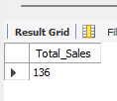

1. write a SQL query to Create Stored procedure in the Northwind database to retrieve Ten Most Expensive Products

**Query:**

CREATE PROCEDURE `get_ten_mostexpensiveproduct`()

BEGIN

select productName , unitprice from products order by unitprice desc limit 10;

END

call get_ten_mostexpensiveproduct();

**Output:**

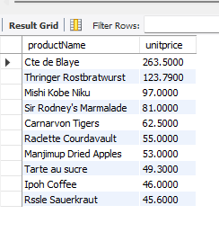

1. write a SQL query to Create Stored procedure in the Northwind database to insert Customer Order Details

**Query:**

CREATE PROCEDURE `insert_cust_orderdetails`( In order_id int(20),In product_id int(20), in unit_price decimal(10,4)

,quantity smallint,discount double(8,0))

BEGIN

insert into `order details`

values(order_id,product_id,unit_price,quantity,discount);

END

call insert_cust_orderdetails(10393,12,100,6,0);

select * from `order details` where orderid = 10393 and productid=12;

**Output:**

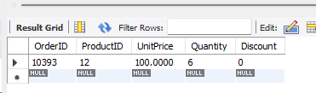

1. write a SQL query to Create Stored procedure in the Northwind database to update Customer Order Details

**Query:**

CREATE PROCEDURE `update_cust_order_details`(In order_id int(20),In product_id int(20), in unit_price decimal(10,4)

,quantitys smallint,discount double(8,0))

BEGIN

update `order details`

set UnitPrice=unit_price,Quantity=quantitys,Discount=discount

where OrderID=order_id AND ProductID=product_id;

END

call update_cust_order_details(10393,12,2000,5,0);

select * from `order details`

where orderid = 10393 and productid=12;

**Output:**

